

The Welbeck Federation of Schools Prospectus

Netherfield Infant & Nursery School and Eastlands Junior School
Address Netherfield Lane, Meden Vale,
Mansfield, Nottinghamshire NG20 9PA Telephone
Netherfield (01623) 842683

Eastlands (01623) 842257 office@netherfield-inf.notts.sch.uk office@eastlands.notts.sch.uk
Co-Executive Headteachers Mrs J Rischer/Mrs J Scott Head of Schools
Mrs L Jordan Chair of Governing Body
Mr S Aubignac

Dear Parents and Carers,

Welcome to The Welbeck Federation of Schools. Netherfield Infant School and Nursery work very closely with Eastlands Junior School to provide your child with the best possible education. This means that leadership is shared across the two schools and that all staff work together to make sure that our children fulfil their potential; from starting at two years old or in the Nursery, until they leave at the end of Year 6.

All staff members will work closely with you and the local community to ensure a strong
family feeling is at the heart of all the work that we do and we hope you feel confident that your child will be happy and successful in our care.

It is very important to us that the children make the best possible progress, achieve well and enjoy learning throughout their school career, as well as becoming valued members of society and we appreciate the contribution that they make to our schools.

Our joint vision statement is:

Working together on our journey to success.

We hope that you will enjoy sharing in and celebrating the range of activities and experiences on offer to the children.

If you are unable to find the information that you are looking for in this prospectus please feel free to contact the schools directly with any queries you may have.

With very best wishes,

Mrs J Rischer Mrs L Jordan
Mrs J Scott
Executive Headteachers Head of Schools

Netherfield Infant & Nursery School is a Community school for pupils from 3-7 and Eastlands Junior school is a Community School for pupils aged 7 to 11.
The Schools
It is our aim to ensure that every child is happy at The Welbeck Federation of Schools and that they achieve to the best of their ability.
Both schools are members of the Meden Family of Schools and we enjoy a very close working relationship with the other schools in our ‘Meden Family.’
At the end of year 6 the majority of children transfer to the Meden School in Warsop.

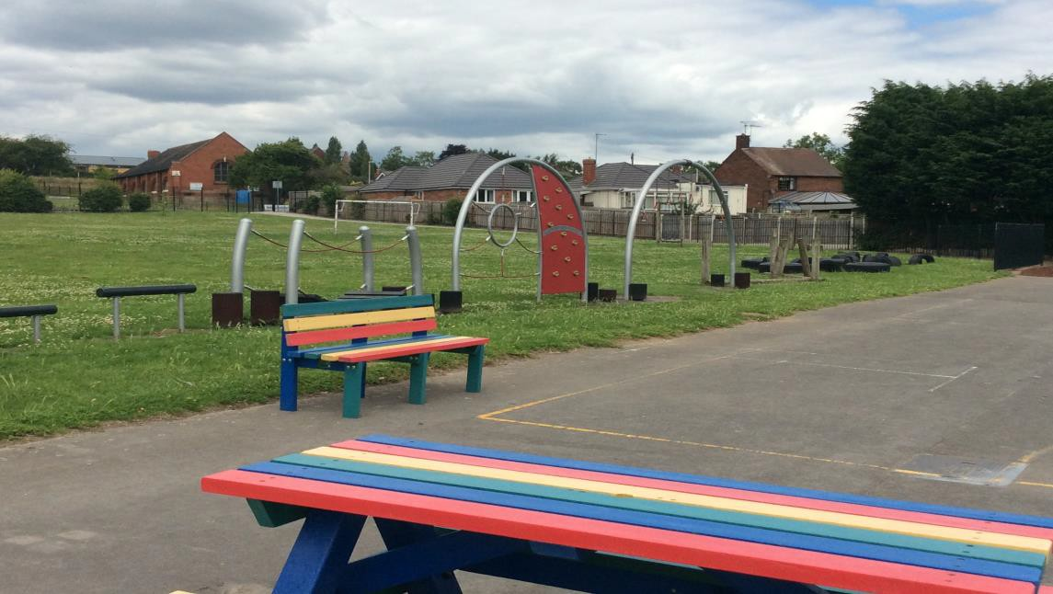

Part of our adventure play area

Our vision is to develop well rounded, confident and responsible individuals who aspire to achieve their full potential. We will do this by providing a welcoming, happy, safe, and supportive learning environment in which everyone is equal and all achievements are celebrated

In order to achieve this -
Our staff will work together to;

- Inspire and enthuse children to learn
- Provide high quality, stimulating learning opportunities, which interest and motivate the children and challenge them to achieve their full potential

- Promote a life-long love of learning
- Listen to, respect and value each child as an individual
- Provide a safe, secure and welcoming environment for all
- Develop a home-school partnership
- Be an encouraging and consistent role model for learning
- Develop confidence and independence in a safe and positive learning environment

Our children will try really hard to;

- Come to school every day, be punctual and well prepared for lessons
- Be motivated, enthusiastic and positive learners
- Be willing to work hard and cooperate with others
- Take responsibility for their learning and aspire to do their best
- Respect others and their environment
- Take pride in all their achievements
- Try new opportunities and experiences,

Our parents/carers will;

- Encourage and support their child and their school by taking an active role in their education and development
- Encourage children to aspire to do their best and celebrate success
- Ensure punctuality and good attendance
- Provide their child with the appropriate equipment
- Share the schools’ expectations and promote the importance of learning
- Communicate with their school to develop a strong home-school partnership

Governors will;

- Be fully committed to their roles and responsibilities
- Support the schools in achieving their aims and aspirations
- Be supportive and encouraging of children, staff and parents
- Monitor the progress of the schools to ensure standards and targets are met
- Support and represent the schools in the wider community
- Ensure that the schools provide a safe and secure environment
- Challenge and support the schools’ management to ensure that all children develop and achieve their potential

Members of the community will;

- Be supportive of children, staff, parents and Governors
- Establish strong links and be pro-active in the life of the schools to enrich the experiences of the children

- Recognise the importance of the schools in the community
- Promote the values of the schools in the wider community

Visiting Arrangements
Parents are most welcome to visit the schools at any time but we would appreciate prior notice of the visit whenever possible. Visits can be arranged by contacting the Executive Head Teachers or Head of Schools via the School Office.
We believe that parents should be encouraged to take a close interest in their children’s education and we therefore provide opportunities throughout the year for parents to visit the schools and be involved in the following activities:
- briefing meetings for parents of new intake children
- meetings to inform parents of curriculum matters
- sporting events
- music and drama productions
- assemblies
- parent and teacher interviews - three per year, with a written report being issued before the end of year interview
- events organised by the Parent Teacher and Friends Association as fund raising activities for the schools.

Admission Arrangements
At The Welbeck Federation of Schools we adhere to the Nottinghamshire County Council procedures for admission. These can be found on our websites, in Nottinghamshire County Council’s "Admissions to Schools" booklet or on line at www.nottinghamshire.gov.uk .
Netherfield Infant School and Eastlands Junior School’s pupil admission numbers for each year group for 2020 – 2021 is 40.

Learning and Teaching Policy
Our Learning and Teaching Policy has been approved by the staff and Governors and will be reviewed annually. It aims to ensure that the children at our schools are provided with high quality learning experiences that lead to enhanced levels of pupil achievement. It is rooted in the aims of the schools and our vision statement.
The policy was developed through a process of staff discussion and consultation with governors, advisers, parents and children and it applies to both schools.

The Curriculum
The Governors are committed to ensuring that a well-balanced, engaging curriculum is provided - A curriculum which is designed to:
- encompass the requirements set out in the National Curriculum for all subjects

- help pupils develop lively, enquiring minds, with the ability to question and argue rationally, and to apply themselves to tasks and physical skills
- help pupils to acquire knowledge and skills relevant to adult life and employment in a fast changing world
- help pupils to use language and number effectively

- promote respect for religious and moral values, and appreciation of other religions and ways of life different from their own
- help pupils understand the world in which they live, and the interdependence of individuals, groups and nations
- help pupils appreciate human aspirations and achievements

- help pupils understand and value human diversity in terms of intellectual and physical abilities and achievement.

EYFS

We deliver learning in The nursery through a method called Planning in the Moment.

The EYFS explicitly states, “Practitioners must consider the individual needs, interests, and stage of development of each child in their care.” Child-led learning is widely regarded as one of the most effective ways of doing that, while in the moment planning is one of the most effective ways to introduce child-led learning.

Child-led learning is particularly effective because it means children are engaged and involved. This is linked to better brain development in developing children.

Planning in the moment is nothing new. It is what a responsive parent does on a day-to-day basis with their children. This is what skilful practitioners do in settings. When an adult looks at and listens to a child, they are making observations about what the child can do, what they need help with, based on prior knowledge of that child. The response will be precisely suited to that child and planned in the moment.

Initially, in the nursery, parents contribute to their child’s learning by informing practitioners of their child’s interests and any significant events that are happening in their lives. The practitioners then use this information to create a topic/interest based medium term plan. The plan is used to prepare the environment using the children’s interests. The environment supports all children to be

fully engaged in purposeful play of their own choice and interest. 3-5 children are chosen to be focus children every week. This means when the practitioner works with those children the observation, intervention and what the child was able to do due to the adult support is documented. This is shared with parents and targets are set in collaboration with each other to move the children’s learning forward.

Reception class use this pedagogy in planning for learning experiences for the children but it is adapted to enable the children to progress though the early learning goals.

Subjects Taught

Our KS1 and KS2 curriculum aims to meet the needs of all children. It is taught largely through skills and knowledge based cross-curricular themes, which are centred around a key text. It ensures that the appropriate programmes of study and attainment targets set out in the National Curriculum (2015) are covered.
National Curriculum Core Subjects are English, Maths and Science

Maths - Our maths teaching aims to provide a foundation for understanding the world, the ability to reason mathematically, and a sense of enjoyment and curiosity about the subject. Our curriculum aims to ensure that all pupils:
- become fluent in the fundamentals of maths so that they can recall and apply their knowledge rapidly and accurately
- reason mathematically, making generalisations, developing an argument, justification or proof using mathematical language
- can solve problems by applying their mathematics to a variety of problems with increasing sophistication
English - Our teaching of language and literacy is developed as integral aspects of the teaching of every subject, as well as being taught as a subject in its own right. Our English curriculum covers:
- Spoken language (Standard English)
- Reading and comprehension.
- Vocabulary writing, composition and handwriting.
- Spelling, grammar and punctuation.

Science – Science topics are divided into the individual year groups.
Year 1
- Plants
- Animals, including humans
- Everyday Materials
- Seasonal Changes Year 2
- Living things & their Habitats
- Plants
- Animals, including humans
- Use of Everyday Materials

Year 3
- Forces and Magnets
- Rocks
- Light
- Animals (including humans) and Plants Year 4
- Living Things and their Habitats
- Animals (including humans)
- States of Matter
- Sound
- Electricity Year 5
- Living Things and their Habitats
- Earth, Space and Forces
- Properties and Changes of Materials
- Forces
- Animals (including humans)
Year 6
- Living Things and their Habitats
- Animals (including humans)
- Evolution and Inheritance
- Light and Electricity

Computing - A computer system with access to the Internet is set up in each classroom and each school has a set of lap-tops and a set of I-pads which are used across the school.

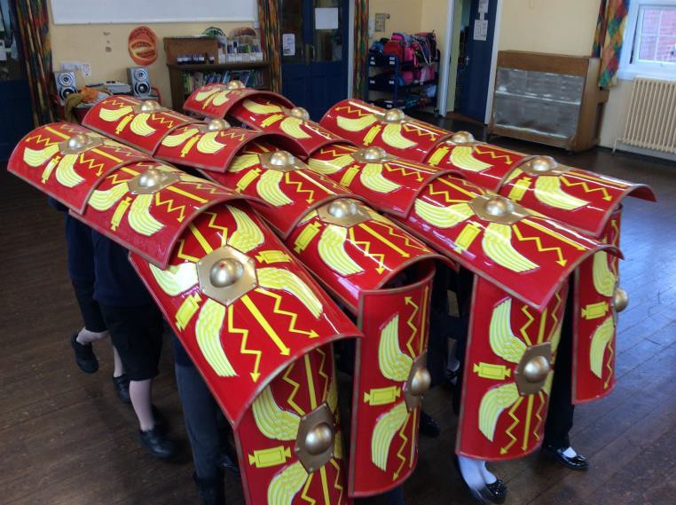
Year 3/4Roman Day

- Foundation Subjects
  - History
  - Geography
  - Design Technology
  - Art
  - Music
  - RE
  - PSHE
  - P.E. and Games,
  - Swimming (KS2)
  - French (KS2)

We believe that our children need visits, visitors and experiences to ensure that they have a rich and varied curriculum. We use our pupil premium provide as many of these experiences as we can.
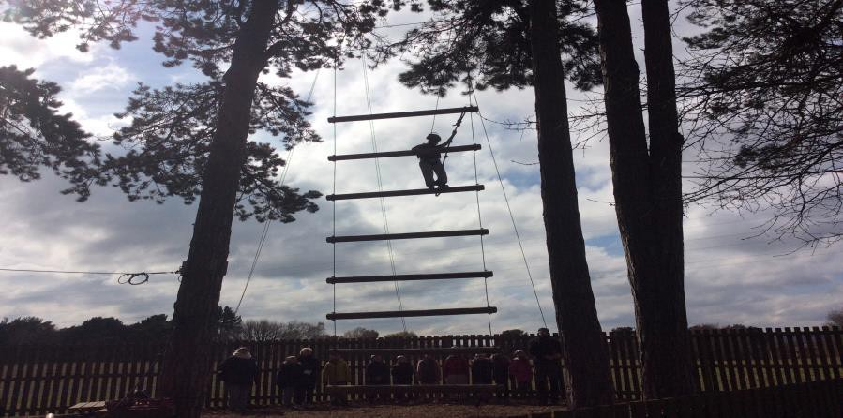

Over KS2 children will have the opportunity to go on a residential visit. The children always have an amazing time.
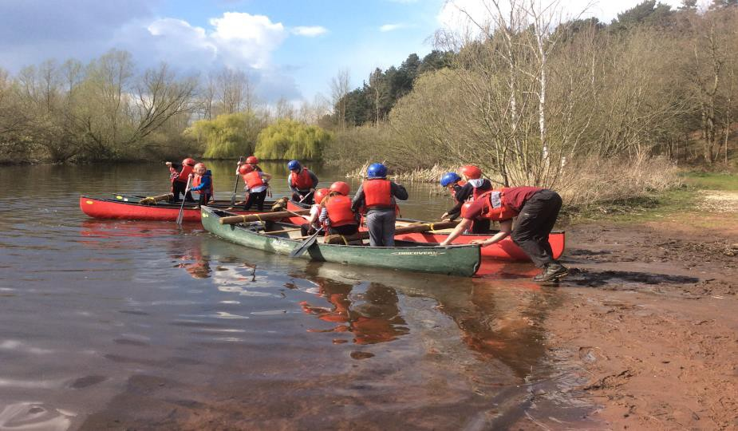

Religious Education policy

The Religious Education taught in the schools is based on the Nottinghamshire Agreed Syllabus. School Assemblies are held each day and parents may exercise their right to withdraw their children from taking part in school worship and religious instruction, if they so wish, on religious grounds.
Religious affiliation

The schools are not affiliated in any way with any particular religious denomination. Sex Education
This is taught in accordance with the guidelines issued by the Nottinghamshire Education Authority, and approved by the Governing Body. A copy of this policy is available in school.

Complaints
There is a procedure agreed by the Local Authority for dealing with any complaints about the school curriculum and other related issues and a copy of the full complaints procedure is available for reference on the school website.
The procedure provides:

a) that usually there will be a preliminary informal discussion with the Executive Head Teachers, Head of Schools or other appropriate school staff to see if the complaint can be resolved without recourse to the formal procedures.
If a formal complaint is to be lodged, the Executive Head Teachers or Head of Schools will be able to provide the complainant with copies of the relevant documents explaining the arrangements for considering the complaint in more detail.

Documents available
The documents listed below are the ones which are required to be made available under Regulation 6 of the Education (School Curriculum and Related Information) Regulations 1989.
- The L.A.’s statement of curriculum policy.

- The Governing Body’s statement of curriculum aims for the schools

- All statutory instruments, circulars and administrative memoranda concerning the curriculum which are sent to schools by the Department for Education.
- All published HMI reports which refer to the schools.

- All schemes of work currently used by teachers in the schools.

- All syllabuses followed where appropriate.

- The L.A.’s procedure for dealing with complaints about the curriculum.

- The L.A.’s agreed syllabus for R.E.

- Published Ofsted Reports on the schools –

Netherfield Infant & Nursery School – The most recent, March 2017 rated the school ‘Good’ in all areas.
Eastlands Junior School - The most recent, January 2019 rated the school as “Good” in personal Development, Behaviour and Welfare and “Requires Improvement” in other areas and overall.
If you need to see or acquire any of the above documents, these will be made available to you by the Executive Head Teachers or Head of Schools, after prior notice.

Organisation of classes
The children are in four classes as outlined below. Netherfield Infant & Nursery School
Class | Teacher | Teaching Assistants
Nursery | Mrs C. Goodall | Mrs P Broughton
Reception | Miss S Harwin/Miss G North | Mrs C Buck
Y1/Y2 | Mrs L Patrick & Mrs V Parkin | Mrs S Burbidge
Y2 | Mrs J. Turner | Mrs J Croshaw

Eastlands Junior School

Class | Teacher | Teaching Assistants
Y3 | Mrs L Bradshaw
Y4 | Mr A Lilley | Mrs M Fay
Y5 | Miss L Ward | Mrs A Robinson
Y6 | Miss C Brown/Mr M Brightman | Mrs J Short

Special teaching arrangements
Special Educational Needs can vary from children with basic learning difficulties to the most gifted children. Help is provided for children with special educational needs by organising extra in-class support. In some circumstances the assistance of the authority’s special support service is utilised.
The Senco for both schools is Mrs J Turner

Parental involvement

Home/school reading
Parents are encouraged to become involved in the schools’ Home/School reading project. Parental support for this has proved to be an important factor in the success of the children’s reading progress. Parents are asked to support and sign the Home/School Agreement found in the Reading Diary/Personal Organiser and to sign the children’s reading record to evidence that they have heard the child read at least five times per week.

Phonics and Spellings
Parents are encouraged to help their child to learn their phonics, keywords and spellings.

In KS2 homework is set every week. Members of staff welcome parental help in the schools where it is appropriate - cookery, football, reading in school, swimming, outings etc.

Parents, Teachers and Friends Association
This is a group of parents and interested friends who arrange social events for children, parents, and families and fund raise for the benefit of the school. Parents of children new to the school are positively encouraged to get involved with this group who are very active and who are a great support to the school - providing resources and equipment that the school budget is simply unable to provide. Please see Mrs Rischer or any member of staff for further information. There is also a display board with additional details. For any other information please contact the office.

The care of children
The children remain with one teacher throughout most of the year, and during that time the teacher comes to know each child in the class extremely well, so establishing a good and caring relationship, which is so essential to the child. The class teacher is directly responsible for the care of each child in his/her class under the guidance of the Executive Head Teachers and Head of Schools. Whenever problems arise, parents are immediately consulted.
In case of illness in school, a telephone number or address of a relative or neighbour must be provided for each child. Minor injuries, i.e. cuts or grazes, are dealt with by members of staff. In cases of more severe injury, parents are contacted and arrangements are made to take the child to hospital.

School behaviour
We do expect children to behave well at all times and we ask for the cooperation of all parents in this matter. Where a serious matter is concerned, the parent will be informed and privileges withdrawn. In some cases parents will be invited into school to discuss their child’s behaviour and any further action that may be taken.

Copies of our policies on behaviour and bullying are available in both school offices and on the school’s web-sites.

Sport
The Welbeck Federation of Schools aims for all children to be physically active and enjoy physical activity. We hope the children will develop a healthy lifestyle and positive attitudes to fair-play and sporting behaviour. Through our P.E. curriculum the children experience games, gymnastic activities, dance, athletic activities, outdoor and adventurous activities and swimming.
The time spent on these activities is usually around two hours per week. Additionally there is an opportunity for boys and girls to participate in extracurricular sports clubs which operate at different times of the year, very much depending upon weather and other school commitments. Eastlands Junior School has a large football pitch on site and the green field space adjacent to Netherfield Infant School is also utilised. We have specialist PE experts, who take each class for PE once a week. They also run three lunchtime clubs and an after-school club at Eastlands, to ensure skills are taught accurately e.g. hockey, tennis, multi-skills etc. One of the specialist PE coaches runs a Respect through Sport programme and also provides alternative sports provision,
e.g. archery and lacrosse during lunchtime.

Eastlands Junior School Extra-curricular societies and activities
The school organises extra-curricular activities. Most of the following clubs are currently in place. Multi-skills Sports Club
Football Club for girls and boys (run by a qualified FA coach.) Gardening
Computing Club Choir Homework

The school and the PTFA also organise regular discos for the children.

School dress
Girls:

- Red/White shirt
- Grey skirt or pinafore dress
- Black or grey trousers
- Red cardigan or pullover or sweatshirt
- During the warmer months of the year, red and white checked or striped dresses are worn. Boys:
- RedWhite shirt
- Black or grey trousers
- Red pullover or sweatshirt

- During the warmer months of the year, black/grey shorts may be worn.

Uniform is available from Brigade. Details are available in the school’s office and on the websites. Footwear
We appreciate the co-operation of parents in fitting out their children with sensible, low-heeled footwear. Training shoes, open sandals, stiletto heels, high-heeled boots/shoes are not suitable.
P.E. lessons

We expect boys to wear:-navy or black shorts with a white tee shirt, and black or white plimsolls. For outdoor PE, boys should wear navy or black jogging bottoms and a sweat shirt and trainers. Logos and hooded sweat shirts should not be worn.
Girls should wear:-navy or black shorts, white T- shirt, black or white plimsolls. For outdoor PE, girls should wear navy or black jogging bottoms and a sweat shirt and trainers. Logos and hooded sweat shirts should not be worn.
All P.E. kit should be kept in a small, named bag and left in school from Monday to Friday. Jewellery
Although the wearing of jewellery such as earrings other than plain studs is not allowed. In the interest of safety, teachers will ensure that pupils remove their jewellery during PE and sport. Teachers themselves are not allowed to remove or replace earrings in children’s ears. We cannot accept responsibility for the safekeeping of jewellery. Additionally we cannot put platers on a child’s ears to cover ear rings.

Services from which the school benefits
The school is very well supported by the following services which are provided by the Authority; further details of these can be found in the Nottinghamshire County Council’s brochure, ‘Going to School in Nottinghamshire’.

For the support of Children and Staff
- Early Help Unit
- Inclusion Support / Educational Psychology Service
- Child Health Service
- Equality and Achievement Team
- Environmental Education
- In-Service Training - provided to ensure that members of staff are kept up to date with the changes and initiatives constantly taking place in the field of education.
- Advisory and Inspection Service - to monitor the quality and standard of education provided in the schools.

Suspected child abuse
- Every school in Nottinghamshire is required to follow a set procedure in cases of suspected child abuse. Head Teachers are required to refer their concerns to the Social Services Department (via the Multi-Agency Safeguarding Hub) for further investigation so that children at risk can be quickly identified.
- This procedure is intended to protect children from abuse. When a school refers a concern about a pupil to the Social Services Department, it is not accusing the parents of abuse but requesting that further investigation takes place to establish whether a child is at risk.
- School has designated safeguarding leads, Mrs Rischer, Mrs S Graham, Mrs Turner and Miss Butler are the safeguarding team. Jo Rush (chair of governors) is the safeguarding governor.

School attendance
At The Welbeck Federation of Schools we strive to maintain a good attendance record, but rely heavily on parental support. All parents are made aware of the importance of their child’s regular attendance at school. We have an established procedure which should be followed in informing school, should your child be absent.
- If your child is absent from school for any reason, e.g. illness, dental or medical appointment, please telephone school on the first day of absence and send a written explanation to school on your child’s return.
- In the case of dental, doctor and hospital appointments, please give notice to the class teacher in writing.
- Holidays taken during term time will not be authorised, unless they are for exceptional circumstances. Parents who take their children out of school for a holiday may be served a Penalty Notice of £60 per parent per child, which increases to £120 per parent per child if not paid within 21 days. For additional information relating to holidays in term time, please see the school’s Attendance and Punctuality Policy.
- Children arriving at school after the completion of the class register at 9.00 am will receive a late mark.
Attendance Governors will visit regularly to examine the registers, home visits will be made by the Family Liaison Worker
All “unauthorised absences” taken by your child has, by law, to be written on his/her school report. The Local Education Authority also has to be notified of these.

Special Needs
The schools adopt an approach to Special Educational Needs and Disabilities (SEND) which clearly focuses on identification and strategies for dealing with those children with SEND in our schools. We always try to be available for support, counselling and sympathy and to re-assure parents that the school has their child’s interest and welfare at heart. Parents are regarded as partners, especially when their child has a special educational need.
There is equal access to the curriculum and equal opportunities for all with Special Educational Needs or Disability - regardless of whether or not the child has an Education Health Care Plan (This used to be known as a Statement of SEND).
In providing for SEND the school follows the stages laid down by the DfE Code of Practice. The school’s policy on Special Educational Needs and Disability is available from the office and on the school’s website.
We aim to be an inclusive school and implement new legal requirements to the best of our ability. Mrs J Turner is the SENCo for the schools.

Disclaimer
The information given in this brochure which relates to the school year 2024/2025 was valid at the time of printing. It should not be assumed that there will be no changes affecting either the arrangements generally described in this brochure or in any particular part of them before the start of the school year 2024/2025 or in subsequent years. Any anticipated changes have been included as part of the text.

